Information is Art

Information can be a dance or a symphony. Or it can be a melée or a cacophony. Just as a choreographer brings together many people and elements to form a ballet and a composer melds an alchemy of sounds to form a symphony, so the developers of information systems create art from chaos.

As one of my classmates, Smita Avasthi, eloquently stated, "I cannot help but think that art conveys and transforms information until it is elegant; without that elegance, information ceases to be useful and falls into stasis." The gathering and transformation of information into an elegant whole is an art. The technologies that will make this art possible are now emerging. They will allow information to come to us—rather than our chasing after it—in a pleasing and easy-to-use format.

A cacophony

What we are trying to achieve in our information universe is like bringing together many instruments to form an orchestra. The information that we have today on our computers and on the web is like many instruments playing solo. At this point in our information development we must continue to go to dozens of sources to get what we need. The ideal is to have information flow to us as we require it or want it in an organized and streamlined way. How do we bring this barrage of information into harmony?

New developments in Internet customization are in the works. The interactive web is on the horizon. The advent of web services is bringing about an Internet that filters information for us. USA Today featured an article called “Internet to ask, ‘How may I serve you?’” on October 27, 2005, that is about this notion of a customized Internet. Kevin Maney writes, “For the past decade on the Net, you’d click and get a web page. If you wanted more information, or to order something, you’d click again. The user has had to do a lot to navigate around.” Now we are coming into an era in which the Internet will bring the information to us in an elegant package—“automated websites that use XML to go looking for things for you” [emphasis mine].

And in what language?

The first step is for everyone to agree on a common language in which to write this Internet harmony. XML (Extensible Markup Language) is one method, but there are other methods as well that are competing to become the standard. No doubt it will take decades (if not longer) for a standard to emerge, just as it took centuries for standard music notation to develop. As Richard Rastall writes in The Notation of Western Music (1998), "the story of musical notation in Western Europe is one of innovations, changes and disappearances." Similarly, creators of information services find themselves in the infancy of the development of the language in which to express and amalgamate information. Competing and incompatible systems vie for supremacy. “Since the Semantic Web is still at its early stage, it might be too early to enforce any standardization. Each representation language can grow on its own and the one or a few ones who win will become the de facto standards” (Lu, et al., 2002).

The information portal

As language standards develop, people are also searching for the best ways to package this customized information. If I may use another art metaphor, this interactive web will come to us as a painting of our own design. The web page will become the canvas onto which we “paint” the information sources that we need. Anyone who needs information will become the creator of individual information portals—a clickable canvas through which information flows. Ellen Fischer (1998) states in “The Many Uses of XML,”

XML documents will begin sitting next to the HTML [hypertext markup language] documents to shuttle information back-and-forth between the web page and the database. In addition, anyone who has access to the XML DTD [extensible markup language document type definition] can use a script to draw information from another web page into his or her own. Microsoft's Charles Heinemann describes a method in which one can put weather updates, stock quotes, baseball games scores and movie listings directly on her page by using XML and ActiveX.

This canvas has become known as an “information portal.” It is a page that brings together customized information from disparate sources. Various applications are being developed to allow users to bring content to them. One of the ways in which people are bringing information from scattered sources together is through RSS (Really Simple Syndication). “Soon we'll see RSS portals with user-rated channels, cool RSS site of the day, build your own topic-specific portal, and highly relevant search engines. A collective weblog would be another intriguing possibility. May the best content win” (King, 2000).

Business software developers are creating portals for their clients’ employees that allow the employees to personalize their entry into the business’ network. One type of customization is called “Employee Self-Service.” “With Employee Self-Service, users find all the services and information needed to carry out their organizational and administrative tasks quickly and easily at one location in the portal on their desktop” (Bangert).

Employees can design their portal page with various mini-applications, “Generic MiniApps,” that can be “positioned in a portal page by the user”:

‘MiniApps’ are accessed by the user whenever he/she needs a certain information. So they are only of interest for a short period of time but may be accessed quite often to monitor a process, for example the Mail inbox. The content of a MiniApp can be pushed or pulled, or is quite stable - whatever seems appropriate from a user's point of view. (Arend)

Less and less will people have to comb the Internet for the information they need. Instead, they can put together a palette of information sources and applications on one page. Ramona Winkler writes:
A portal should:
- automatically present its users with the information appropriate to the user's role
- suggest additional information to the user, and/or allow the user to voluntarily personalize the information presented by the portal
- allow the user to search for information that was not previously known to be relevant to the user's role, but which may be available through the portal

My perfect portal

What would I paint into my perfect information portal? I decided to take a look at the dollhouse miniatures business that my partner and I run from our home (www.vandijkminiatures.com). We conduct most of our sales online via eBay; some of our business is done through attending trade shows. In order to run our business we have these sorts of information needs:

- Show locations and dates, table fees, and affordable accommodations.
- Up-to-the-minute eBay auction information, including customer payments and merchant fees.
- Competitor information.
- Customer information: names, addresses, past purchases, balances due, etc. and the ability to aggregate and sort this information to look for trends. We even keep track of which customers have pets and other personal snippets in order to personalize our service.
- Supplier information and past ordering history.

As it is now, in order to find information about these various things I have to visit numerous web sites and open several different applications on my computer. To find out about shows, there are several dollhouse miniatures sites and print sources that list upcoming events. I have to comb through their listings to find shows that match my parameters. To find accommodations, I then have to look through a number of travel web sites such as Expedia or Travelocity.

For eBay information, I go to a bookmarked page that shows our sales. For Paypal information, I must log into their site. To monitor our competitors, we must search through eBay’s dollhouse miniatures category and bookmark the pages of the people who make similar items.

Our customer info is at the moment quite inefficiently stored. Our invoices are stored on an old Macintosh Performa computer in a proprietary invoicing program, which means the data are locked away forever and cannot be transferred to a PC or even to a newer Macintosh. The emails we send to our customers go through our PC in Outlook Express, and we use eBay’s invoicing to send invoices to them. There is a lot of duplication of data and effort in this set-up.

Designing the page

I will show here how I would streamline these information needs into one portal page. My graphics will show the box that would appear on my page and one of the outside sites I have to visit now to get that information.

First, to get show information, I would have a box on my screen that allowed me to enter my search parameters: types of shows, geographic locations, table fees, and dates. The ‘bot that I unleash will scan the web for the information I need and bring back to me a listing of specific shows that match my criteria. I will be able to save the shows listing to my portal page so that I can access information about those shows whenever I need it.

Show information
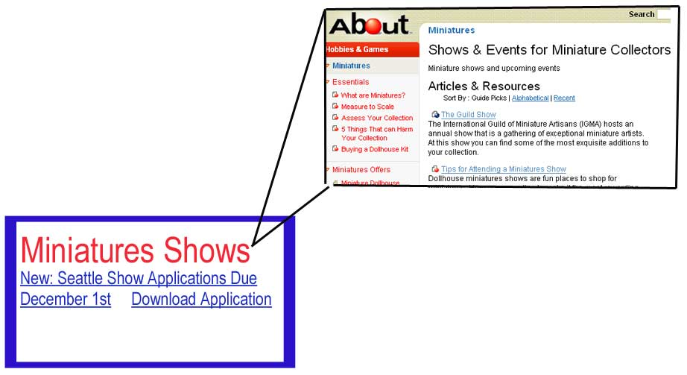

My XML-enabled calendar will find deposit due dates and show dates and will automatically enter them into my calendar (which also sits in one corner of my portal).

I will have a travel/accommodations box on my portal page that already “knows” my preferences in airlines, hotel types, price, and location. I can simply type in the city I will be traveling to, and it will retrieve for me a list of flights and accommodations from which I can choose. I will be able to book the reservations right from my portal.

Travel/Accommodations
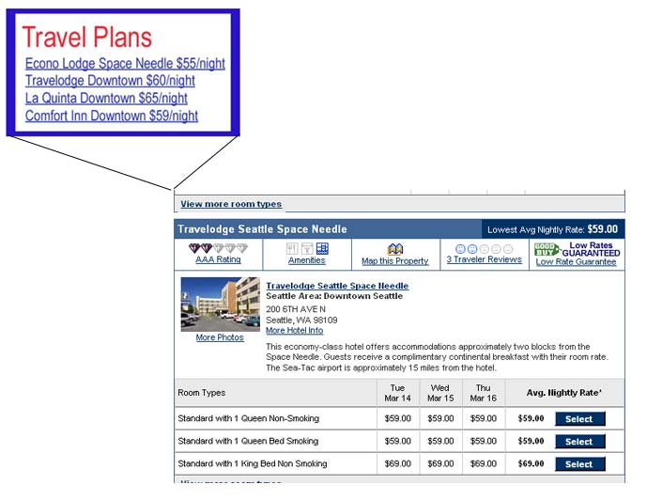

I will be able to keep tabs on my competitors with information that eBay sends to a box in my portal. I will receive alerts when someone new comes on the scene who is featuring similar items.

Competitor information
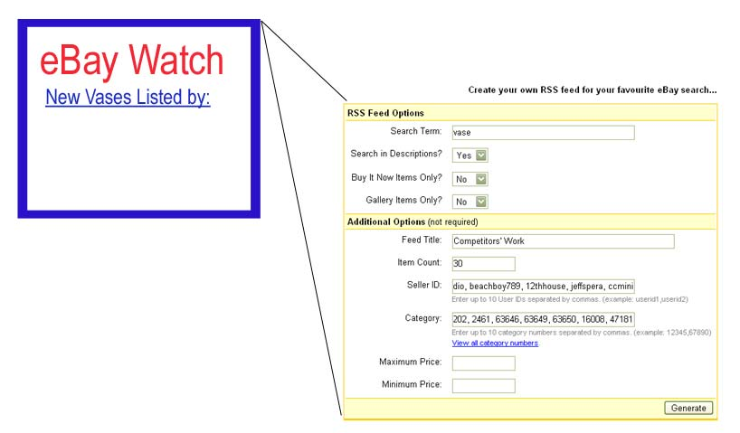

My invoices box will keep tabs for me on who has paid and needs their order shipped and whose payments are overdue.

Invoices
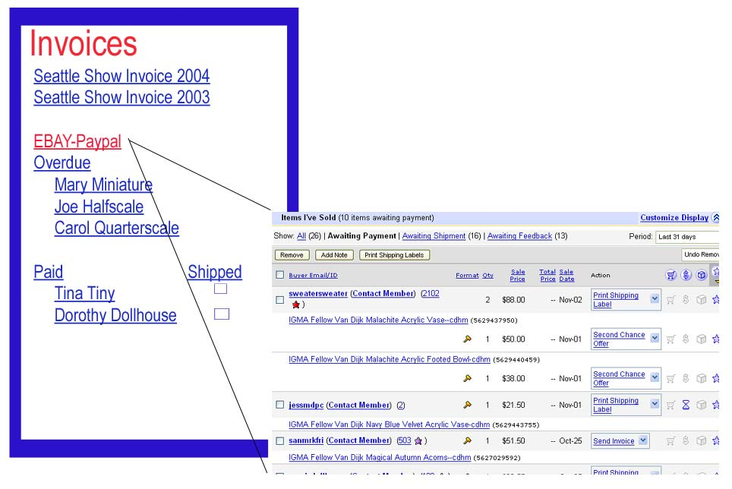

My suppliers and most recent orders will be listed so that I can place re-orders at any time.

Suppliers
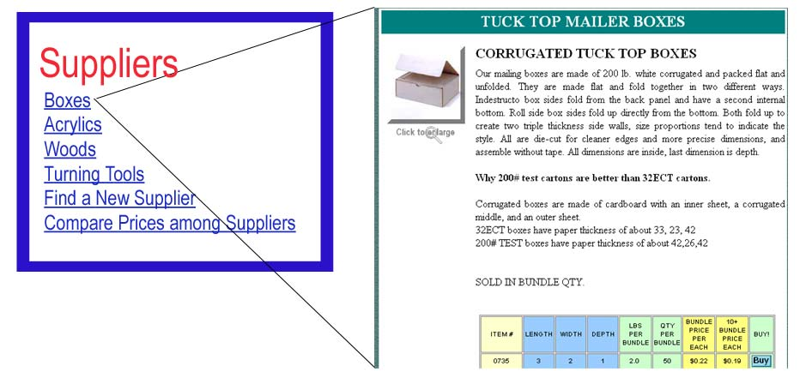

Defining workplace

Having my business information in one place would make life so much easier for me and my partner. For now, we do the best we can to organize our information, but we spend a lot of time chasing down sources. Though I cannot yet use this fictional portal that I have developed, I hope to be able to have such a page in the near future.

Portals will be used in business, the classroom, and for leisure pursuits. In addition, I see the day coming when a person can go to the library’s reference desk and be “issued” a customized research portal page—filled with sources and elements to direct a patron to the information sources he or she needs both within the library’s walls and out in cyberspace.

The role of designers and developers is going to undergo a radical shift. Waloszek states, “we found that the role of usability people and user interface designers may change from designing screen elements and singular applications to a more holistic approach of designing work places for people.” The work place will become a cyber location rather than a physical place.

Some might say that all of this portal design is technical—not artistic. Music composition can be technical as well, but it is also art. Painting with watercolors or oils requires knowledge of colors, mixing, and technique; yet it is still art. Portal design is the art of crafting an information work place on an Internet canvas. It too is art.

References

Arend, Udo. “Generic MiniApps (iViews).” Retrieved from the Internet on November 22, 2005, at: http://www.sapdesignguild.org/editions/edition3/gen_iview.asp.

Bangert, Ulf. “Employee Self-Service and Life and Work Events – Two Ideas for a New User Centric Perspective.” Retrieved from the Internet on November 22, 2005, at: http://www.sapdesignguild.org/editions/edition3/ess_wle.asp.

Fischer, Ellen E. (1998 ) “The Many Uses of XML.” Available at: http://www.sis.pitt.edu/~mbsclass/standards/fischer/XMLUses.html.

King, Andrew B. “Introduction to RSS.” (Created: March 27, 2000
Revised: April 14, 2003), Available at: http://www.webreference.com/authoring/languages/xml/rss/intro/l.

Lu, Shiyong, Dong, Ming and Fotouhi, Farshad. (2002) "The Semantic Web: opportunities and challenges for next-generation Web applications." Information Research 7(4), Available at: http://InformationR.net/ir/7-4/paper134..htm.

Maney, Kevin. (October 27, 2005) “Internet to ask, ‘How may I serve you?’” USA Today.

Waloszek, Gerd. “Portal Usability – Is There Such A Thing?” Retrieved from the Internet on November 22, 2005, at: http://www.sapdesignguild.org/editions/edition3/portal_usab.asp.

Winkler, Ramona. “Portals – The All-In-One Web Supersites: Features, Functions, Definitions, Taxonomy.” Retrieved from the Internet on November 22, 2005, at: http://www.sapdesignguild.org/editions/edition3/portal_definition.asp.

